Interviews - Top Title Reps
Ryan Raphael, Gabriel Crecion, Lexi Hutchings, Marco Andrade

Consolidated Insights
- High Rep Adoption: Top reps (Ryan, Gabriel, Lexi, Marco) use Genie daily or near-daily; see it as core to their sales process.
- Agent Adoption Low: Reps generally gatekeep; most agents don’t use Genie directly. Agents prefer reps to run analytics, generate kits, or impersonate them.
- Biggest Value:
  - Farm analysis and turnover insights (unique differentiator).
  - Insider Reports and market stats for listing presentations & open houses.
  - Listing Command & Paisley AI for outreach campaigns.
- Biggest Pain Points:
  - Support: universally poor or nonexistent.
  - Data freshness/accuracy: doubts without “last updated” transparency.
  - Technical reliability: broken QR codes, missing listings.
- Strategic Risk: If Genie is sold broadly, differentiation for top reps (esp. Ryan) is diluted — some suggest limiting access.

Summaries by Rep

1. Ryan Raphael – First American (Laguna Niguel, 9/2/25)
Perception of FA & Tech
- Critical of First American: “FA has shit the bed when it comes to tech.”
- All title companies offer similar realtor tools; little differentiation.
Use of Genie
- Uses Farm Genie multiple times daily (2–7x).
- Leverages analytics (farm performance, turnover, owner occupancy, etc.) to secure meetings.
- Positions Genie insights as exclusive and valuable — “What if I told you three neighborhoods are prime for the picking?”
- Rarely gives agents full access; prefers they come back to him for info (control strategy).
Agent Adoption
- Direct agent adoption is low — top producers (10–100M agents) already have CRMs, dialers (Vulcan7), etc.
- Data/analytics-oriented agents are the exception.
- Suggests Greg Ives (San Diego) uses Genie successfully for campaigns.
Differentiator
- Ryan’s personal team ensures closings go smoothly — service + analytics combo.
Concerns
- If Genie is sold to all reps, it loses exclusivity/differentiation. Suggests limiting per county.

2. Gabriel Crecion – Lawyers Title (Westlake Village, 9/3/25)
Adoption & Value
- One of the earliest and most consistent users (daily).
- Uses Genie to help agents focus farms for maximum ROI (highest turnover, lowest competition).
Issues & Gaps
- Data freshness unclear; recommends “last updated” date shown.
- Major frustration with support:
  - No real help beyond texting Steve.
  - Chatbot and contact forms ineffective.
  - Agents have been burned, many stopped using.
- Only advanced users (e.g., Listing Command experts) can fully benefit without support.
Enterprise Setup
- Covered by Lawyers/FNF enterprise relationship.

3. Lexi Hutchings – Lawyers Title (San Diego, 9/5/25)
Usage & Adoption
- Team of 3 (“So Cal Title Gals”); at least one uses Genie daily.
- Relies heavily on Insider Reports (neighborhood/zip versions), Farm Genie, and realtor ranking stats.
- Agents love competition insights; useful in listing presentations.
- At sales meetings, Genie considered “hard to live without.”
Agent Engagement
- Invites agents, but typically impersonates them to run campaigns/reports.
- Agents impressed by AI tools (Paisley property descriptions, flyers, social posts) but rarely use directly.
- Uses Genie to produce polished listing kits and social content agents can execute.
Issues
- Some QR codes in listing kits unreliable (esp. floor plans) → should be removed.
Enterprise Setup
- Company pays; reps don’t directly.

4. Marco Andrade – Fidelity (Simi Valley/Westlake Village, 9/12/25)
Usage & Value
- Daily/near-daily user. Says Genie “substantially changed my business.”
- Uses:
  - Market Insider Reports for open houses, door knocking, lead capture.
  - Listing Command for circle prospecting, text blasts (cheaper than postcards).
  - Paisley AI for structured engagement plans (scripts for text/email/phone).
Agent Engagement
- Invites selectively; many agents don’t know how to use it.
Enterprise Setup
- Initially expensed half, later FNF paid fully due to performance.
Issues
- Customer service is poor — long delays/no response.
- Technical issues: Some listings not showing up in Listing Command (reported Sept 8, 2025).

Raw Notes
Title Rep Interviews

9/2/25

1. Ryan Raphael - FirstAm
Top National Title Rep
Laguna Niguel

- His view is that "FA has shit the bed when it comes to tech"
  - All the title companies have the same set of realtor tools on their corporate websites
- The Genie
  - The Farm Genie has been the tool that's gotten Ryan lots of meetings with agents
  - He would approach agents and ask "how well are your farms performing?"
  - All the title companies have farm property data by neighborhood, but The Genie has enabled Ryan to show agents analytical info that is valuable and that they cant easily get anywhere else
- Inviting Realtors
  - Big fan of "gluing himself to the transaction"
  - he doesn’t make a habit of giving agents access - instead they come to him for information
- On other tools that are out there
  - "I have enough meetings. I need Quality"
- Mock sales pitch using Genie data
  - Ryan to agent - "What if I told you there are three neighborhoods that are prime for the picking"
- How title reps get business
  - Normal scenario is realtor will give Ryan all listings that come from the farms he gives the realtor
  - So Ryan gives the realtor richer analytics on those farms so agent can be more efficient in getting listings
  - Then they have to come back to him to get more info
  - Ryan doesn’t give away reports and data, but he often types out a snapshot of the info an agent needs
- FirstAm has all the "farm" areas as well as
- Inviting realtors
  - "the data has not been great"
  - Generally 50% accuracy on data is pretty good (email, etc)
  - Mojo? Have a Dialer? Do they have Vulcan7?
  - Vulcan
    - A dialer program - cold calls (phone and email)
    - Hooks up to their CRM
    - If the realtor already has a CRM
- Inviting agents to the Genie
  - Ryan has not had good results with getting the agents using the Genie tools directly
  - Ryan is chasing the 10-100 million agents
    - They usually have their own CRM, marketing, outreach, cold calling, etc tools
    - What they need is guidance - Aka the analytics
      - Example - Owner occupancy data
  - The exception is agents who are into data and analytics - they can benefit from direct access to data, but only if they have a person on the team that into that (or if the realtor is more of an engineer type data geek)
  - Suggests I talk to Greg Ives - San Diego
    - uses it a lot. Text campaigns, email blasts.
- Ryan's differentiator as a rep
  - Has his own team in Laguna Niguel that stays on top of all closings, status, knows the title issues. He makes sure deals close!
- Ryan's Genie Usage
  - He is in there everyday … 2-3 times a day - today he was in there 7 times
  - Today was with an agent team farming a few areas. Making sure it makes sense to market the area
- More Genie Value?
  - Ryan doesn’t think he is using the tools to the full extent
- Trends
  - All the brokers now have their own title companies

- Post call - Genie internal
  - Concern - If The Genie is the differentiator, what happens when we sell it to all title reps?
  - Is there value in limiting usage to a certain number of reps per county?

9/3/25

2. Gabriel Crecion - Lawyers Title
Westlake Village

- Gabriel
  - One of the first reps on the system
  - Has used it consistently (daily) used over time
- Value?
  - Analyzing Farms and putting agents in the best spot - to get the most out of their marketing dollars
- Issues?
  - Over time - not sure if the data has been refreshed over time
    - Suggestion is to show a "data updated as of" date
  - Support
    - "There is no support - zero"
    - Only support is to text Steve
    - The chatbot doesn’t help, and the contact forms don't go anywhere
    - Gabriel doesn’t know if data is still right - when property and tax data
      - Assessor info, owner has to be accurate
- How often use it?
  - As a rep, every day
  - A lot of people have been burned by bad support so they've stopped using it
  - If you're an expert in Listing Command - good. Otherwise, no support on how to use it
- How do you use it?
  - Show and tell in front of a realtor
    - Prior to meeting - discovery
      - What tools they have (CRM, marketing platform, etc)?
      - What they spend on marketing?
      - New or experienced agent?
    - Overall goal is to find the highest turnover with the least amount of competition
    - No one else has this - The turnover (velocity) score Top realtors
    - Go through each bullet point initially

- Who pays for it? You or company?
  - Lawyers has an enterprise relationship (thru FNF)

9/5/25

3. Lexi Hutchings - Lawyers Title
Area

- About the Rep
  - Team of 3 "girls" in Dan Diego - "So Cal Title Gals"
- How often use it?
  - At least one of them is using the Genie Daily
- What makes it valuable?
  - The value is there but hard to get agents to use it
  - Rep has to do everything for them
- How do you use it? (show me)
  - Uses the insider report
    - Usually the neighborhood versions and the zip code versions
    - Uses when an agent has a new listing
    - Or a listing coming up (can be used in the listing presentation)
  - Agents love the agent competition information
  - Uses Farm Genie a lot
    - Pick a zip code, and area, and get all the cool stats
  - Also looks up realtors individually for stats on them
    - Useful to show the agent their ranking in certain areas for ex.
  - At sales meetings
    - Sales manager will periodically go over the sales tools and which ones they can get rid of.
    - It'd be hard for Lexi to do her business without the Genie
- Do you invite agents?
  - Yes. In order for Lexi to impersonate an agent, they have to be invited and accept the invite
- If so, how do they use it
  - RE agents are "in awe of the ai piece"
    - But they don't really use it directly
  - She often impersonates the agent to generate the listing kit
    - Lots a good flyers and images for social posts
  - Agents are wowed by the Paisley "Property Description"
  - Listing Command
    - Rep can impersonate and set it all up (eg texting), then agent executes the campaign
- Who pays for it? You or company?
  - Company pays b/c Lexi doesn’t pay directly
- Issues or Improvements?
  - Some of the QR codes on the listing kit flyers don't work (eg, floor plans)
    - Just remove those if they're not reliable

9/12/25

4. Marco Andrade - Fidelity
Area

- About the Rep
  - Simi Valley, Moorpark, Westlake Village
- How often use it?
  - Some weeks, daily. Some weeks, close to daily.
- What makes it valuable?
  - "Understanding the product totally changed the game for me"
  - "Substantially changed my business"
  - Market share and statistics - tells agents who is dominant
- How do you use it? (show me)
  - Market Insider Report
    - Open house use case. Print it out and leave it on the counter. People coming by want a copy of report - say "I only have one, but sign up here" - get leads
    - Good to use for door knocking
  - Listing Command
    - Use for Circle Prospecting
    - Uses text message blast - links to branded listing page
    - Cheaper than post cards -
  - Paisley ai
    - Engagement plan. Full walk through step 1, 2, 3. Shows exactly what to text, email or say (if phone call)
- Do you invite agents?
  - Only selectively
  - Sometimes they've been invited, but they don't know how to use it.
- If so, how do they use it?
- Who pays for it? You or company?
  - Started by expensing half of the subscription
  - Then FNF paid for it all b/c performance
- Issues or Improvements?
  - Trouble getting customer service. Months where I got no response
  - Inconsistencies in Listing Command. Starting August, some listings aren't showing up
    - September 8 - Marco reported this info below via chat
Marco Andrade
3:44 PM
Listing are not populating or available to commence a listing command.
#1 2636 Fallen Leaf Ct, Simi Valley, CA 93063 MLS ID: SR25175449
#2 2149 Clover St Simi Valley, CA 93065 MLS ID: SR25098964
#3 991 Clear Sky Pl, Simi Valley, CA 93065 SR25067679
I see this as a reoccurring issue. Please advise ASAP.

- Triple charged for text example
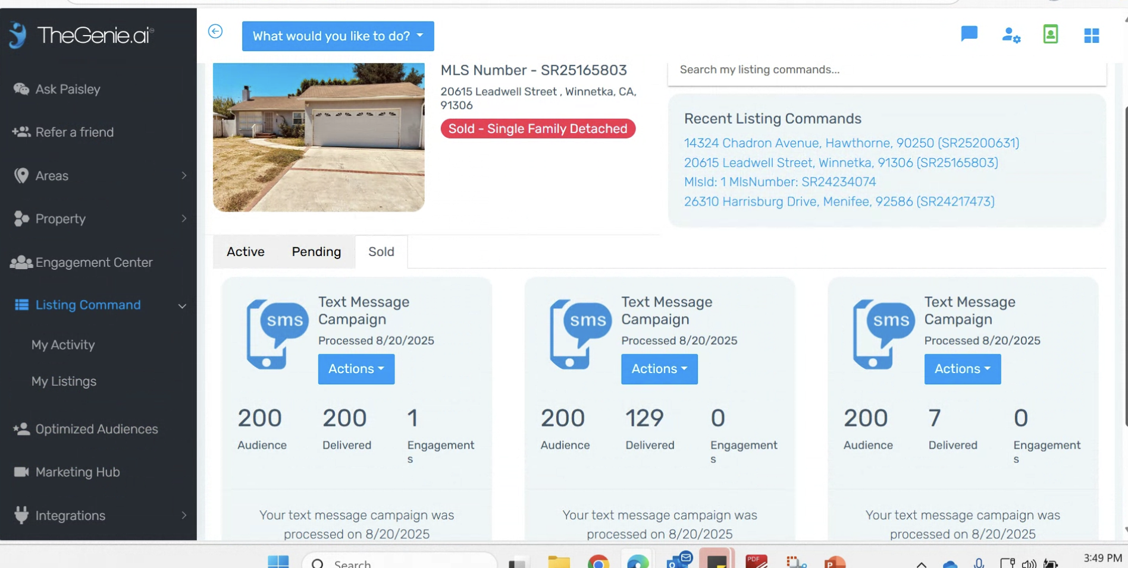

- Listing Command ALWAYS skips the "Select Area" step below. If you don't know what you're doing, it’s a mess.
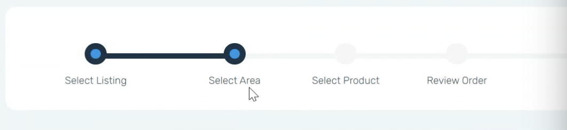

- Value
  - CONFIDENTIAL Marco has a deck he presents to agents. Example slide here.



